Exercise-2

Login-Registration-Profile

Login Screen :
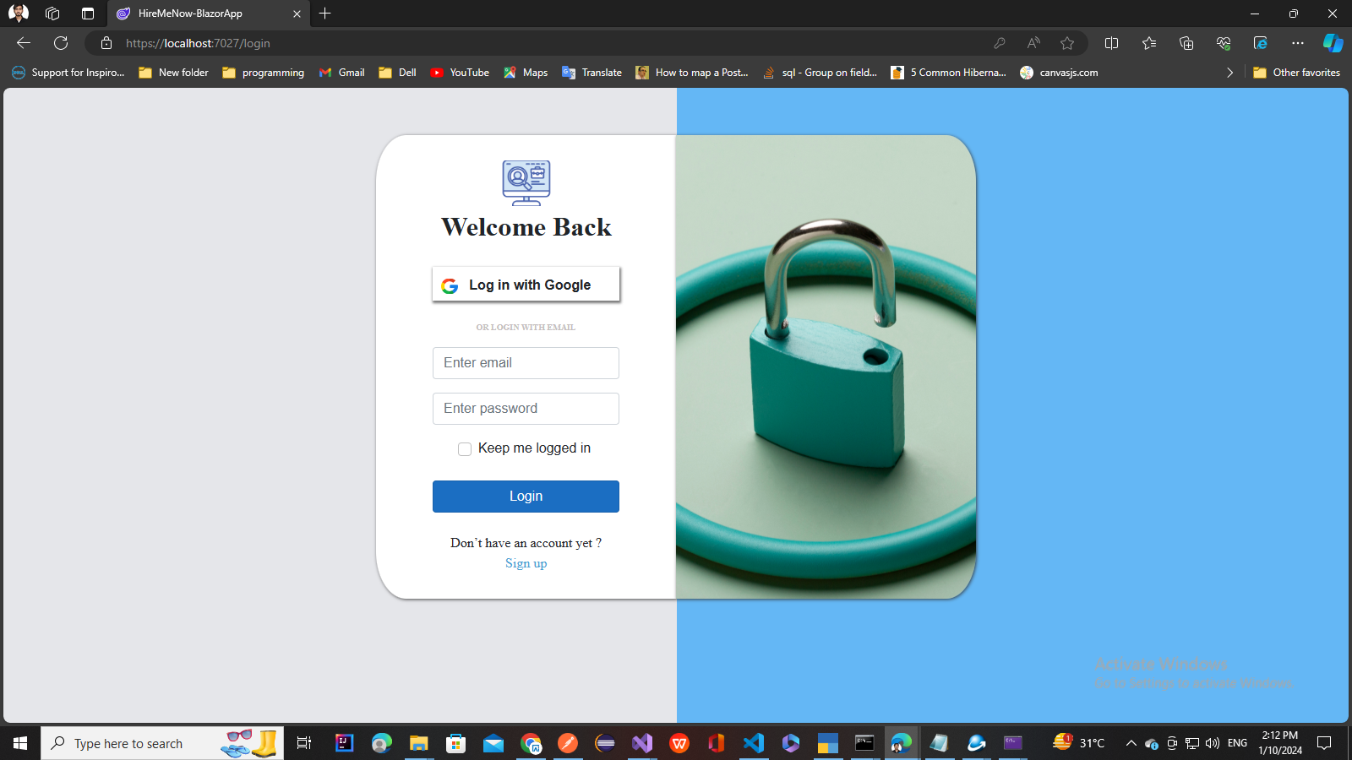

Registration Screen :

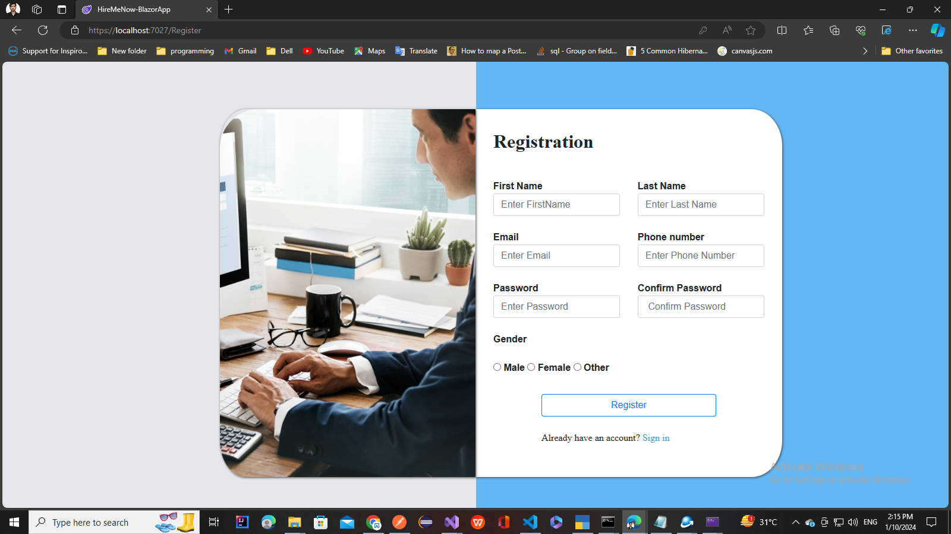

Job list screen
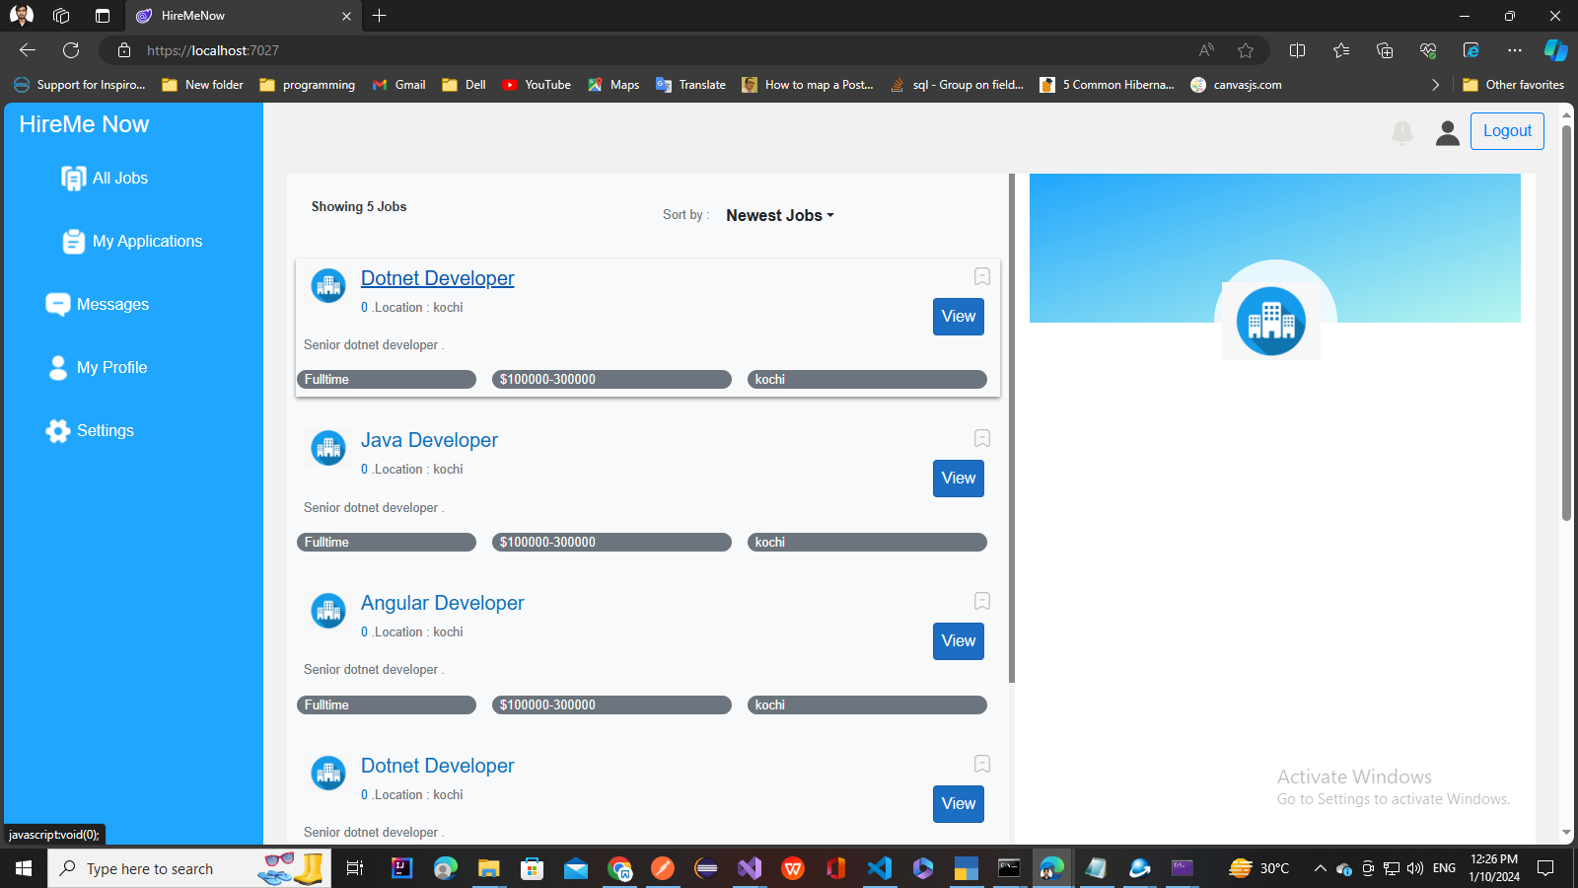

Features to implement:
- Design And Implement Login Screen
- Design And Implement Register Screen
- Design And Implement joblist screen

